**Name/** Ahmed Saeed Abdel Samea Abdel Hamid

**B.N/**

**Data/17/7/2020**

**Topic:** Mobile computing

## Application Brief:

Mobile computing is a group of technologies, products, services, information technology, and operational procedures that enable users to access relevant accounts, information, resources, capabilities while on the move, and it has spread widely in our time, in conjunction with the great technological development the world is witnessing. These devices contain advanced operating systems such as ISO, Android, etc.

And there are many companies that produce smart devices such as Apple, Samsung, Sony and others, and it is possible to do some of the many tasks through those devices, the role of which is not limited only to sending and receiving as with old phones, Rather, it is possible to browse through the Internet, and many applications can be downloaded, and these devices work Touch smart feature and one of the advantages of these devices is that they represent the comfort of the user.

**I chose this app for the following features:**

**Mobile computing has changed the whole landscape of our everyday life. The following are the main advantages of mobile computing: -**

1- Flexibility of use and has become an essential thing in all personal and business use.

2- The flexibility of the site.

3- It saves time.

4- Fast and profitable productivity.

5- Ease of searching and obtaining information.

6- Entertainment, culture and social media.

**Screenshots:**

**Page1**

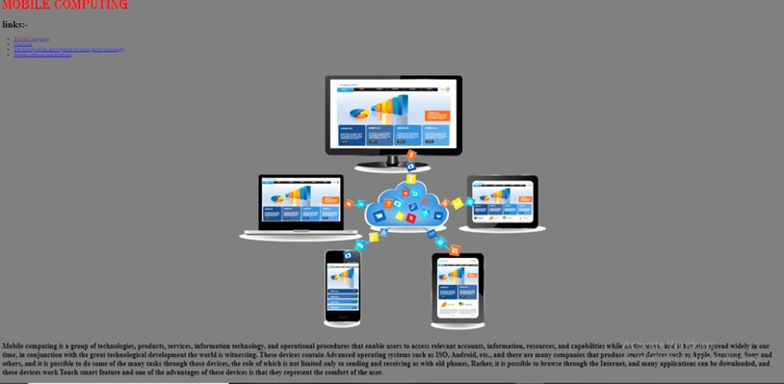

**Page2**

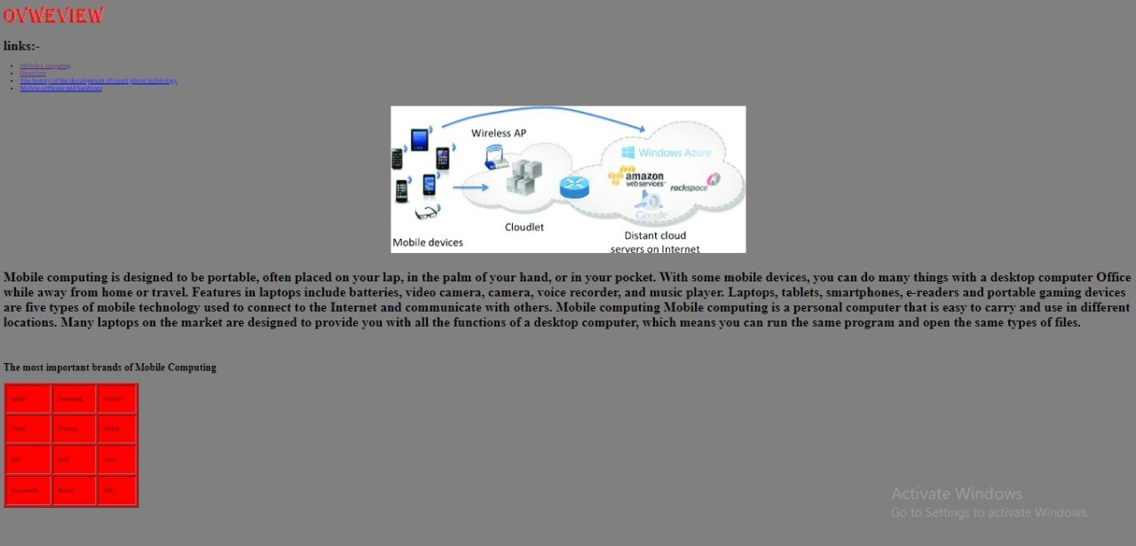

**Page3**

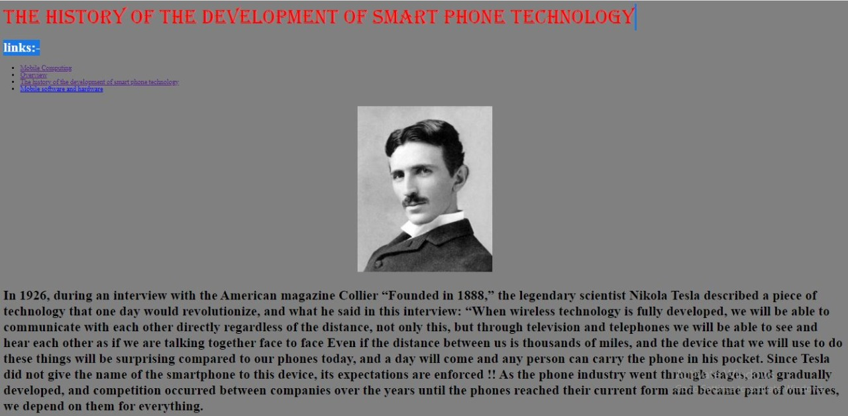

**page4**

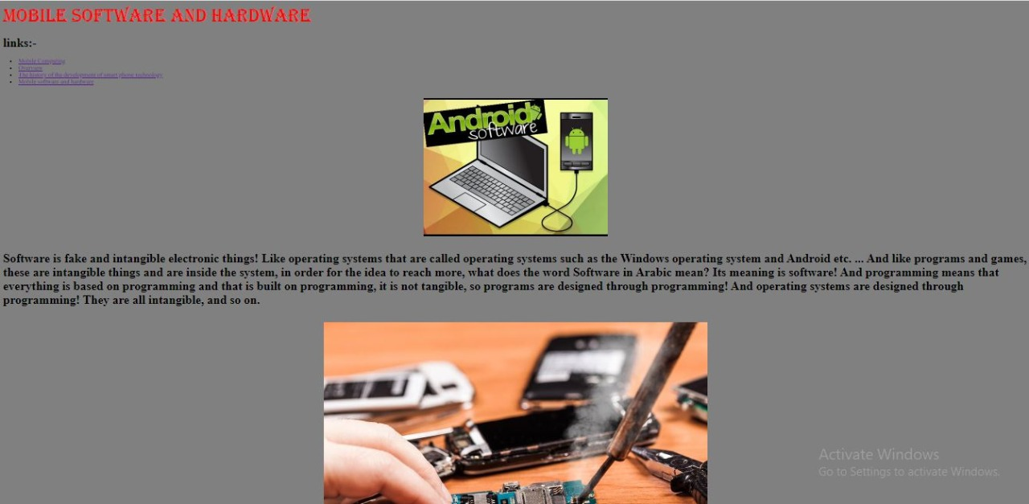

**Screen code: Four pages coding**

